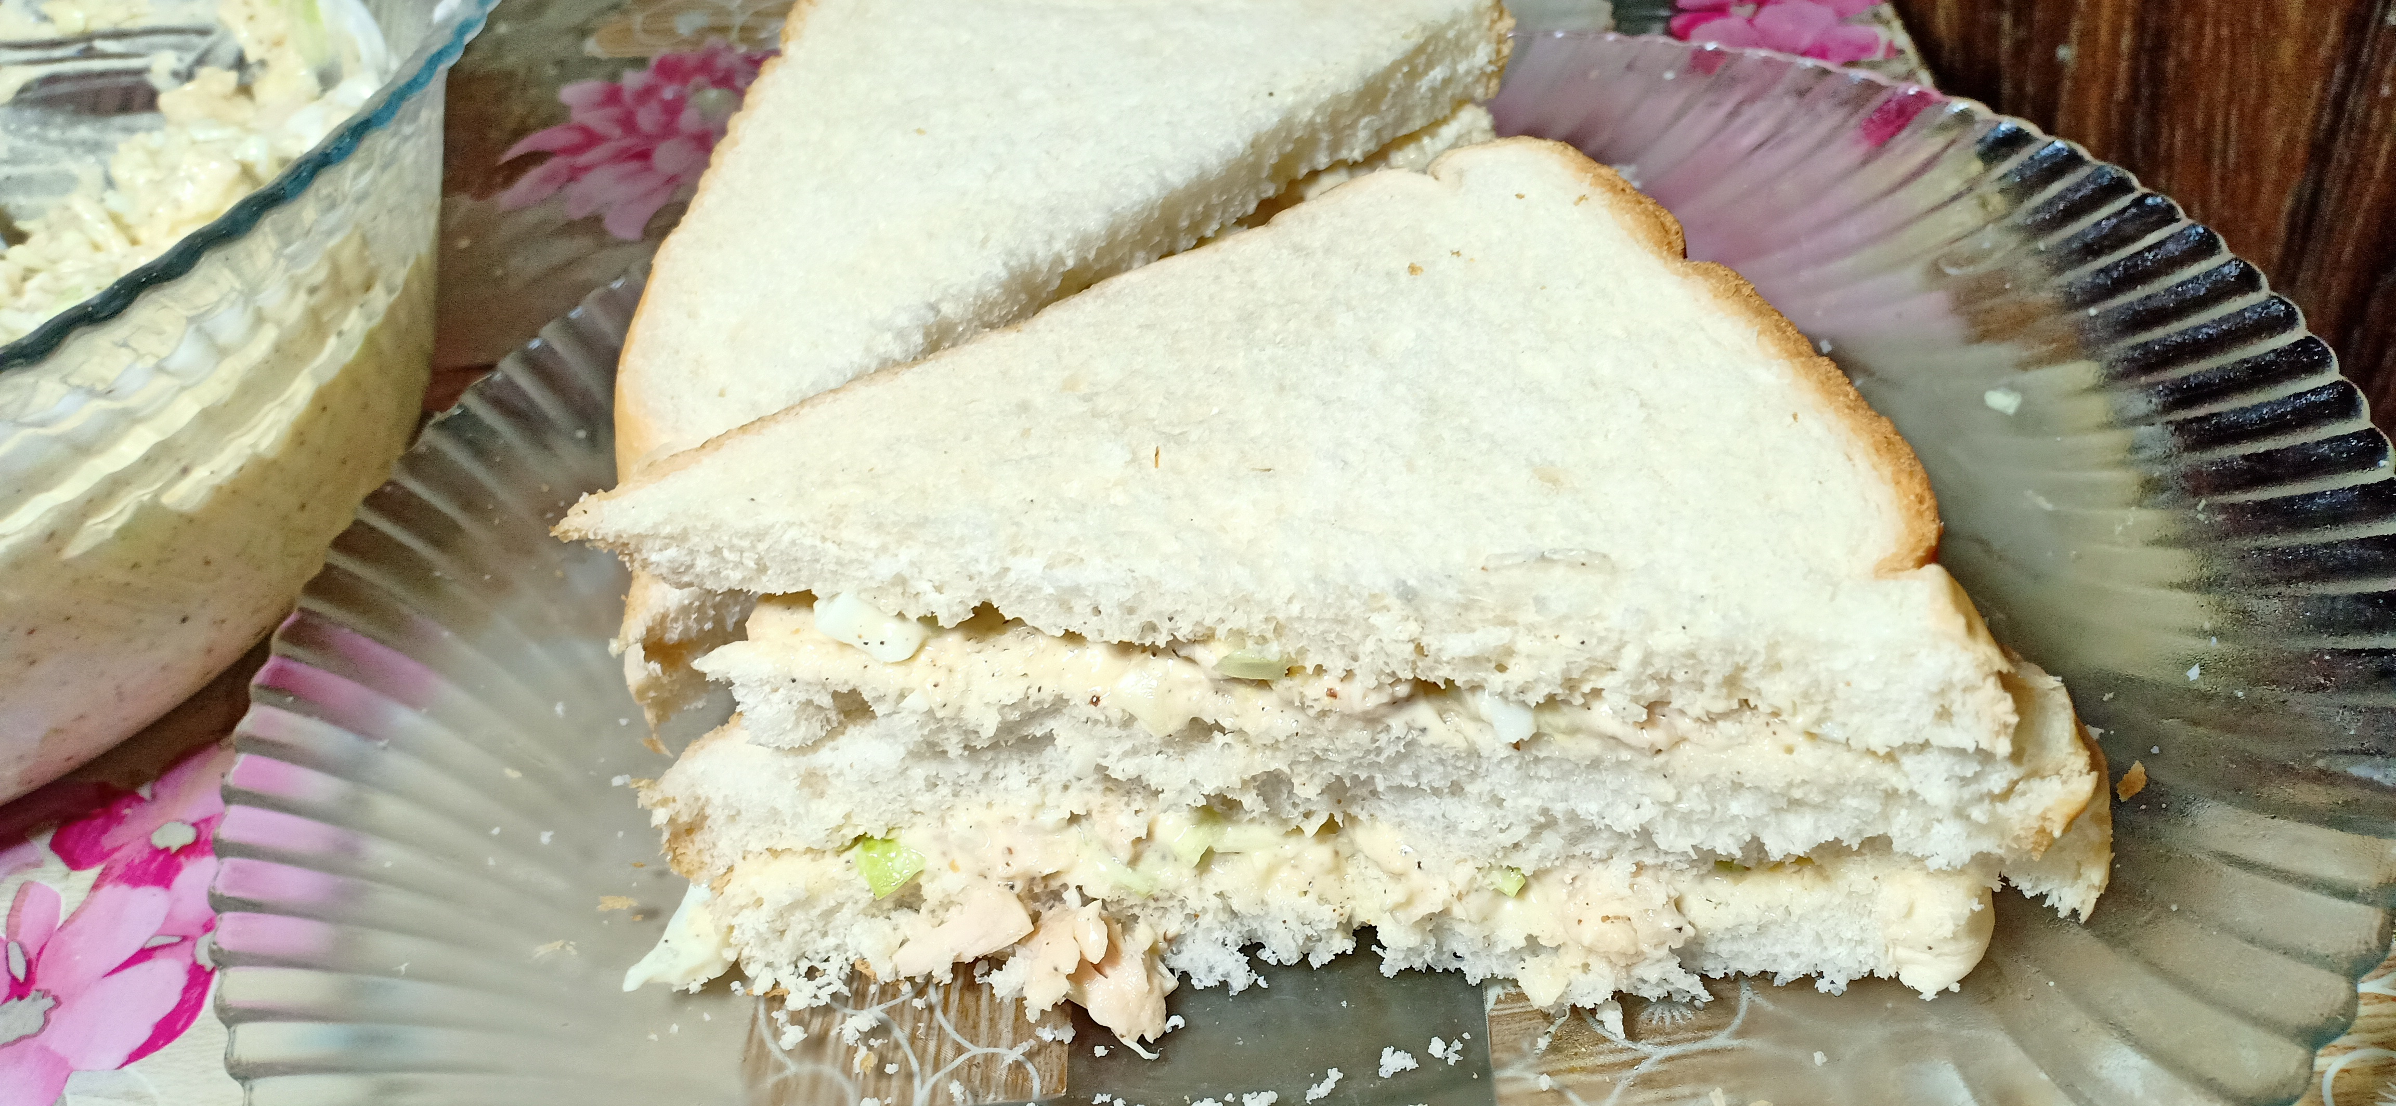

**Ingredients**

* ¼ kg Boiled shredded chicken
* ½ tablespoon salt
* 4 boiled chopped eggs
* 1 cup chopped cabbage
* 1 tablespoon black pepper
* 1 cup / ¼ kg mayonnaise
* Breads as per requirement

**Recipe**

* Add cabbage , egg , chicken , salt and black pepper to mayonnaise and mix it .
* Add the mixture to bread and enjoy.